Hands-On Lab
Period Close Agent
Installation, Close Scenarios and Extending the Agent with Business Skills
Dynamics 365 FastTrack
Solution: PeriodCloseAgentV2, version 1.1.0.0 | Legal entity: USMF | Closing period: October 2026
Contents
Lab Overview 1
Architecture at a Glance 1
Your Lab Environment 1
Lab Files 1
Part 1 — Install and Configure the Period Close Agent 1
Prerequisites in Dynamics 365 Finance 1
Step 1 — Verify the Agent Enabled Field 1
Step 2 — Verify the Dynamics 365 ERP MCP Server 1
Step 3 — Verify the Dataverse Virtual Tables 1
Step 4 — Check Your Lab Access 1
Step 5 — Configure the October 2026 Closing Schedule 1
Step 6 — Create the Trial Balance Snapshot 1
Step 7 — Prepare Your SharePoint Site and Journal Files 1
Install the Agent 1
Step 8 — Import the Period Close Agent Solution 1
Step 9 — Confirm the Import 1
Step 10 — Find and Manage the Business Skills 1
Step 11 — Turn On the Agent Flows 1
Step 12 — Enter Your SharePoint Site in the Business Skills 1
Step 13 — Review the Agent in Copilot Studio 1
Step 14 — Test the Agent in the Preview Pane 1
Part 2 — Run Period Close Scenarios 1
Scenario 1 — Review the Close Plan (read-only) 1
Scenario 2 — Run Accounts Payable Currency Revaluation 1
Scenario 3 — Import the IFRS 16 Lease Journal from SharePoint 1
Scenario 4 — Complete a Task, Chain the Next One and Report to the Controller 1
Part 3 — Extend the Agent with Your Own Business Skill 1
Step 15 — Understand How a Business Skill Is Built 1
Step 16 — Plan Your Monthly Depreciation Skill 1
Step 17 — Deactivate the Shipped Skill and Add Yours 1
Step 18 — Add the Monthly Depreciation Task 1
Step 19 — Run the Monthly Depreciation Task 1
Step 20 — Create Your Own Skill 1
How Skills Align with the Closing Schedule 1
Ideas for Your Own Skills 1
Appendix A — Sample Journal File Format 1
Appendix B — Troubleshooting and Known Issues 1
Reset the Lab for the Next Run 1

Lab Overview
In this lab you will install and run the Period Close Agent for Microsoft Dynamics 365 Finance. The agent runs on the Microsoft Copilot harness and works from the live closing schedule in the Financial period close workspace. It reads the close plan, starts the tasks it is authorised to run, carries out the work in Finance and operations through the Dynamics 365 ERP MCP server, records an audit trail and sends governed close communications.
The agent separates how it works from what the business wants. Built-in agent skills hold the fixed procedures (retrieving the plan, gating execution, changing task status, sending email), while business skills stored in Dataverse hold the finance policy for each close task, such as thresholds, account scope or the SharePoint export location. Finance owners can change or add business skills without editing the agent itself, which is what Part 3 of this lab explores.
By the end of this lab you will be able to:
- Verify the Finance and operations prerequisites: the Agent enabled field, the Dynamics 365 ERP MCP server and the Dataverse virtual tables
- Configure an October 2026 closing schedule in USMF so the agent can run selected tasks
- Import the Period Close Agent solution and create its connections with your own credentials
- Review the agent, its tools and its skills in the new Copilot Studio experience
- Run period close scenarios with the agent and check the results in Dynamics 365 Finance
- Author a new business skill in Dataverse and see the agent pick it up
Lab at a glance (approximate times):
Part | What you do | Approx. time
Part 1 — Install and configure (Steps 1–14) | Check the Finance prerequisites, prepare the closing schedule and SharePoint, import the solution, set up skills and flows, and run a first test | 60–90 minutes
Part 2 — Run close scenarios | Review the close plan, run Accounts payable currency revaluation, import an IFRS 16 journal and chain tasks | 45–60 minutes
Part 3 — Extend with business skills (Steps 15–20) | Learn how a skill is built, add a monthly depreciation skill and task, and plan your own skill | 45 minutes
Appendices | Journal file format, troubleshooting and lab reset | Reference

NOTE: Lab environment. Your lab administrator has already enabled the Period Close Agent capability, made the virtual tables visible and created the USMF closing schedule for October 2026. You will verify these items and complete the remaining setup yourself.

Architecture at a Glance
The Period Close Agent is a Copilot Studio agent that orchestrates the close. It never edits Finance and operations data directly; every read and write goes through a governed tool, and every task status change goes through a dedicated Power Automate flow.
Layer | Component | What it does
Agent | Period Close Agent (Microsoft Copilot harness) | Classifies each request, decides which tasks may run, controls task status and summarises the run. Published to Microsoft Teams and Microsoft 365 Copilot.
Built-in agent skills | 13 skills, for example retrieve-close-plan, execute-period-close-task, run-close-task-chain, import-journal-from-csv | Fixed procedures the agent always follows. They cannot be widened by a business skill.
Business skills | 13 Dataverse skills named PeriodClose_* | Finance policy per close task, read at run time through the Dataverse MCP Server. Seven run close tasks, three describe journal imports and three support email and reporting.
Dynamics 365 ERP MCP | Fin & Ops Apps (Dynamics 365) connector | Live reads and writes in Finance and operations: closing schedule, journals, fixed assets, trial balance and more.
Dataverse MCP Server | Microsoft Dataverse connector | Reads the PeriodClose_* business skills.
SharePoint and Mail MCP | SharePoint (Work IQ) and Outlook Mail MCP | Reads journal CSV files, writes trial balance exports and sends close emails.
Power Automate flows | 6 flows prefixed PCA | Mark task started, Mark task completed, Record task audit, Retrieve close plan, plus two triggers that start the agent when a task is completed or started by a person.
Dataverse | Period Close Task Audit table and Period Close Compliance Review app | Stores one audit record per task attempt for compliance review.

Two settings on each closing schedule task control what the agent does:
- Agent enabled is the only switch that authorises the agent to run a task. When it is cleared the task stays manual.
- #autostart in the task name lets the agent continue to that task automatically when the previous task completes. It never grants permission on its own.
- The task name must also match a business skill's routing rule, for example a name containing trial balance or IFRS 16 journal import.

Your Lab Environment
Item | Value
Lab number | <your lab number>
Lab user | <your lab user>, provided on the lab portal
Finance and operations URL | Provided on the lab portal
Power Platform environment | Provided on the lab portal
Copilot Studio | https://copilotstudio.microsoft.com (if your tenant uses the preview of the new agent experience, your lab administrator gives you the preview address)
Power Apps | https://make.powerapps.com
Legal entity and period | USMF, October 2026
SharePoint site | Your own site, created in Step 7 in your tenant, for example https://<yourtenant>.sharepoint.com/sites/<yoursite>
Solution file | PeriodCloseAgentV2_1_1_0_0_unmanaged.zip

NOTE: Identity. Everything in this lab runs as your own lab user. The agent acts on your behalf in Finance and operations, Dataverse, SharePoint and Outlook, so it can do only what your security roles allow.

Lab Files
The lab package contains these supporting files:
File or folder | Used in
Solution/PeriodCloseAgentV2_1_1_0_0_unmanaged.zip | Step 8, importing the solution
Sample journals/Payroll journal USMF D365 USMF.csv | Step 7 and the journal import scenarios
Sample journals/IFRS 9 ECL journal USMF October 2026.csv | Step 7 and the journal import scenarios
Sample journals/IFRS 16 lease journal USMF October 2026.csv | Step 7 and Scenario 3
Screenshots | Source images for this guide
Business skill/PeriodClose_MonthlyDepreciation.md | Sample monthly depreciation business skill that you add to the agent in Part 3
Business skill/PeriodClose_SkillTemplate.md | Blank skill template for writing your own business skills (Part 3, Step 20)

Part 1 — Install and Configure the Period Close Agent
Part 1 has two halves. Steps 1 to 7 prepare Finance and operations, your closing schedule and SharePoint. Steps 8 to 14 install the agent in Power Platform and Copilot Studio and run a first test.

Prerequisites in Dynamics 365 Finance

Step 1 — Verify the Agent Enabled Field
The Agent enabled field on closing schedule tasks controls which tasks the agent may run. Your lab administrator has enabled the Period Close Agent capability; check that the field is available.
- Sign in to Finance and operations and switch to the USMF legal entity.
- Go to Financial period close and open Closing schedule tasks.
- Select the October 2026 closing schedule in Select closing schedule.
- The Agent enabled column is hidden by default. Right-click any column header in the grid and select Insert columns.
- Select Agent enabled in the list of fields, and then select Update. The column is saved in your personalization of the page.
- Confirm that the Agent enabled column is now visible in the grid.
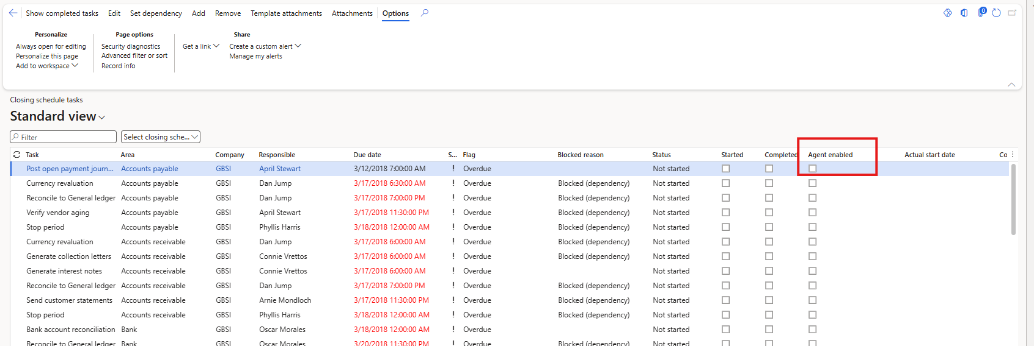
Figure: Closing schedule tasks with the Agent enabled column
NOTE: Showing the column is only for you. The closing schedule tasks data entity always includes the Agent enabled field, so the agent reads it whether or not the column is visible in the grid.
NOTE: If Agent enabled is not offered in Insert columns, the Period Close Agent capability is not enabled in your environment. Contact your lab facilitator before continuing.
NOTE: Production use is gated and controlled by Microsoft. Microsoft enables the Period Close Agent capability for production environments on request; register through https://aka.ms/PeriodCloseAgentSignUp. Lab, evaluation and sandbox environments do not need this step. This gating will change as the capability matures.

Step 2 — Verify the Dynamics 365 ERP MCP Server
The agent works in Finance and operations through the Dynamics 365 ERP MCP server. Check the environment and the server settings before you install the agent.
- Version: 10.0.47 or later (or 10.0.46 PQU-2 or 10.0.45 PQU-7). Version 10.0.48 or later is recommended, because the trial balance and recipient lookup skills use the SQL read tool introduced there.
- Environment type: Tier 2 or above, or a Unified Developer Environment. Cloud-hosted environments are not supported.
Check that the server is enabled:
- Go to System administration > Workspaces > Feature management and select the All tab.
- Search for Dynamics 365 ERP Model Context Protocol server.
- Confirm the status shows it is enabled. If it is not, select it and then Enable now.
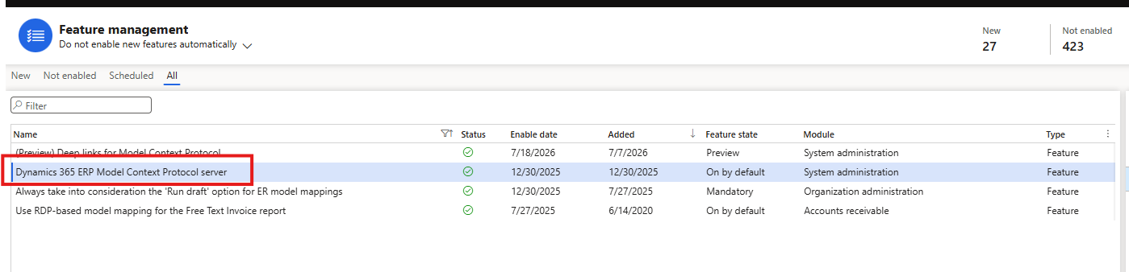
Figure: Feature management with the Dynamics 365 ERP Model Context Protocol server enabled
Check that Copilot Studio may connect to the server:
- Open the Allowed MCP clients page.
- Confirm that Microsoft Copilot Studio (client ID 7ab7862c-4c57-491e-8a45-d52a7e023983) is listed with Allowed set to Yes.
- If it is missing, select New, enter the client ID and set Allowed to Yes.
NOTE: The MCP server never elevates privilege. Each request runs with the roles, duties and data security of the signed-in user, so the agent can do no more than you can do in the Finance and operations client.

Learn more:
- Use Model Context Protocol for finance and operations apps: https://learn.microsoft.com/en-us/dynamics365/fin-ops-core/dev-itpro/copilot/copilot-mcp
- Security for Dynamics 365 ERP MCP (Allowed MCP clients): https://learn.microsoft.com/en-us/dynamics365/fin-ops-core/dev-itpro/copilot/mcp/mcp-security
- Build an agent with Dynamics 365 ERP MCP: https://learn.microsoft.com/en-us/dynamics365/fin-ops-core/dev-itpro/copilot/build-agent-mcp

Step 3 — Verify the Dataverse Virtual Tables
The agent's flows read and update the closing schedule through two Finance and operations virtual tables in Dataverse. Your lab administrator has made them visible; confirm they exist before importing, because the import fails if they are missing.
- Go to https://make.powerapps.com and select your lab environment.
- Select Tables and then All.
- Search for Closing schedules (mserp_ledgerperiodcloseprojectentity) and Closing schedule project tasks (mserp_ledgerperiodcloseprojecttaskentity).
- Open Closing schedule project tasks and confirm it shows rows for USMF.

Step 4 — Check Your Lab Access
Before you continue, confirm that your lab user has everything the agent needs:
- A Microsoft Copilot Studio licence and Environment Maker (or System Customizer) access in the lab environment
- Finance and operations security roles that cover the Financial period close workspace, general journals, fixed assets and trial balance in USMF
- A worker record in USMF linked to your user, with your email address, so you can be the responsible person on close tasks
- An Exchange Online mailbox, so the agent can send close emails to you
- Permission to create a SharePoint site, or Owner rights on an existing site

Step 5 — Configure the October 2026 Closing Schedule
The agent only runs tasks that you explicitly enable. In this step you prepare the USMF October 2026 schedule so that a few tasks route to the agent's business skills.
If your environment has no October 2026 closing schedule yet, create it first:
- Go to General ledger > Period close > Financial period close configuration and open the Closing schedules tab.
- Create a schedule named Oct2026 from the Month end template, for the period 1 October 2026 to 31 October 2026, and select USMF as the only company.
- If you get the error Unable to find any working times, the working-time calendar does not cover the 2026 dates. Create a calendar such as 5DAY2026 (Monday to Friday, 1 January 2026 to 31 December 2027) in Organization administration > Setup > Calendars > Calendars, generate its working times, use it for the schedule, and then create the schedule again.
Then configure the tasks:
- Open Closing schedule tasks and select the October 2026 schedule.
- For each task you want the agent to run, select Agent enabled.
- Rename the task, if needed, so its name matches a business skill (see the table below).
- Add #autostart to the name of any task the agent should start automatically when the previous task completes, for example #Agent Trial balance export #autostart.
- Set Responsible to your own worker so that task emails reach your inbox.
- NOTE: The Responsible worker must have an email address in their worker record. If it is empty, the agent still runs the task but cannot send the review email and records the error UnresolvedRecipient in the audit table.
- Save your changes.
Business skill | Example task name | Area
PeriodClose_TrialBalanceExport | Trial balance export | General ledger
PeriodClose_FixedAssetDepreciation | Fixed asset monthly depreciation proposal | Fixed assets
PeriodClose_FixedAssetAcquisition | Fixed asset acquisition proposal | Fixed assets
PeriodClose_ForeignCurrencyRevaluation | Currency revaluation | Any module (Area selects the variant)
PeriodClose_AccountReconciliation | Reconcile Bank to General ledger | Bank
PeriodClose_VendorAgingReview | Vendor aging review | Accounts payable
PeriodClose_SetPeriodModuleAccess | Close Accounts payable period access | Any module
PeriodClose_PayrollJournalEntry | #Agent Payroll journal import | General ledger
PeriodClose_IFRS9JournalEntry | #Agent IFRS 9 journal import | General ledger
PeriodClose_IFRS16JournalEntry | #Agent IFRS 16 journal import | General ledger

Finally, create the Global Controller marker task. The agent uses it to find who to copy on close emails.
- Add a task named exactly Send email about closing schedule to Global Controller.
- Set its Responsible to your own worker (in a real deployment, the Global Controller).
- Leave Agent enabled cleared on this task.
- Example: the Oct2026 schedule used in the test environment for this lab. Your task names can differ, as long as each one matches the business skill's routing rule.
- Task name in Oct2026 | - Agent enabled | - Business skill it routes to
- #Agent IFRS 16 journal import | - Yes | - PeriodClose_IFRS16JournalEntry
- #Agent IFRS 9 journal import | - Yes | - PeriodClose_IFRS9JournalEntry
- #Agent Payroll journal import | - Yes | - PeriodClose_PayrollJournalEntry
- Process fixed asset depreciation | - Yes | - PeriodClose_FixedAssetDepreciation
- Vendor aging review | - Yes | - PeriodClose_VendorAgingReview
- Reconcile Bank to General ledger | - Yes | - PeriodClose_AccountReconciliation
- Currency revaluation (General ledger area) | - Yes | - PeriodClose_ForeignCurrencyRevaluation
Currency revaluation (Accounts payable area) | Yes | PeriodClose_ForeignCurrencyRevaluation (posts directly)
- Trial balance export #autostart | - Yes | - PeriodClose_TrialBalanceExport
- Send email about closing schedule to Global Controller | - No | - Marker task used by PeriodClose_EmailRecipientLookup

TIP: A task name is matched against one business skill only. If a name could match two skills (for example a generic IFRS journal), the agent stops and asks rather than guessing, so keep names specific.

Step 6 — Create the Trial Balance Snapshot
The trial balance export skill refreshes an existing fiscal-year trial balance snapshot; it never creates one. Create the snapshot for USMF fiscal year 2026 so the export scenario can run.
- In USMF, find the trial balance snapshot page: use the search bar at the top of Finance and operations and type trial balance.
- Create a snapshot for fiscal year 2026 using the main account structure.
- Run it once and confirm the status is Complete.

Step 7 — Prepare Your SharePoint Site and Journal Files
The journal import and trial balance export skills use one SharePoint site that you choose. The agent only reads and writes inside the folder structure below.
- Create a team or communication site, or pick an existing one, and note its exact URL, for example https://<yourtenant>.sharepoint.com/sites/<yoursite>.
- In the default Documents library, create the folder Period Close Agent.
- Inside it, create October 2026, and inside that create USMF.
- Inside USMF, create three folders: Payroll, IFRS-9 and IFRS-16. The agent creates the Trial Balance folder itself.
- Upload the sample CSV files from the lab package into the matching folders, or upload your own files.
Folder | File
Documents/Period Close Agent/October 2026/USMF/Payroll | Payroll journal USMF D365 USMF.csv (this exact name is required)
Documents/Period Close Agent/October 2026/USMF/IFRS-9 | IFRS 9 ECL journal USMF October 2026.csv
Documents/Period Close Agent/October 2026/USMF/IFRS-16 | IFRS 16 lease journal USMF October 2026.csv

NOTE: Build this structure in your own tenant. The site, folders and files shown in this guide are an example only. Create your own site in your tenant, recreate the same folder structure (Period Close Agent > October 2026 > USMF > Payroll, IFRS-9, IFRS-16), upload one CSV file per folder, and note your site URL. If a folder holds two CSV files, the agent stops before writing anything. You will enter your own site URL into four business skills in Step 12.

Install the Agent

Step 8 — Import the Period Close Agent Solution
- Go to https://make.powerapps.com and check that the Environment picker in the top right shows your lab environment.
- Select Solutions.
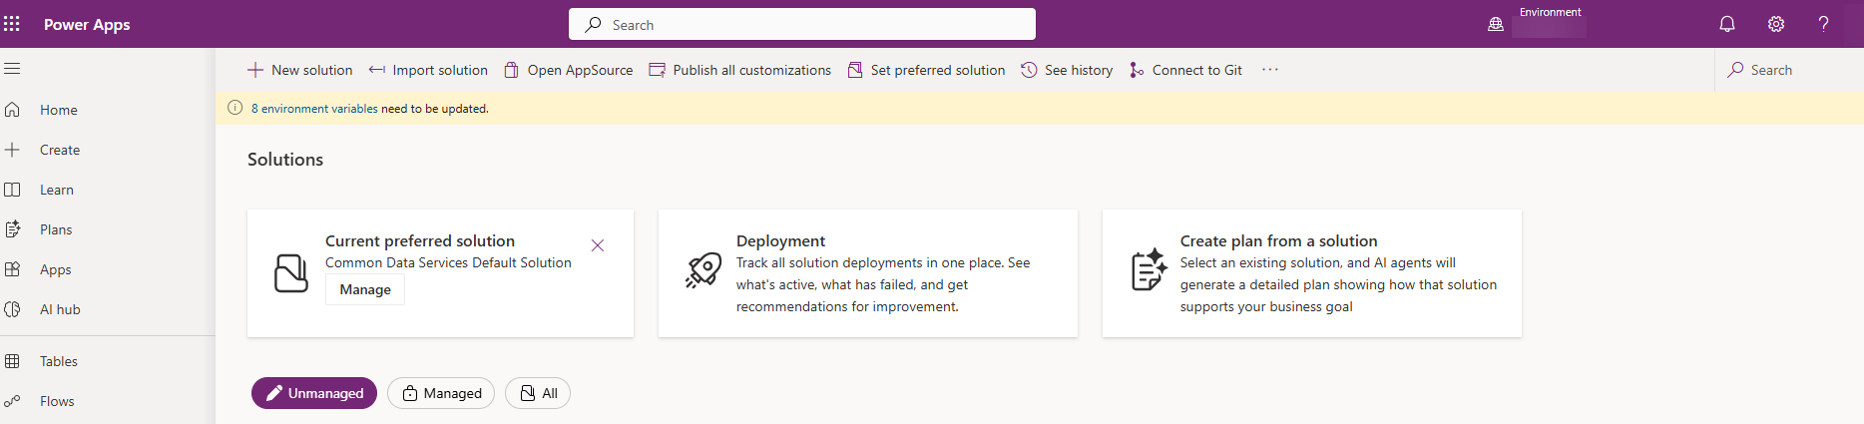
Figure: Solutions page in Power Apps
NOTE: A yellow banner such as 8 environment variables need to be updated comes from other solutions in the environment. The Period Close Agent solution has no environment variables, so you can ignore it.

- Select Import solution, and then Browse.
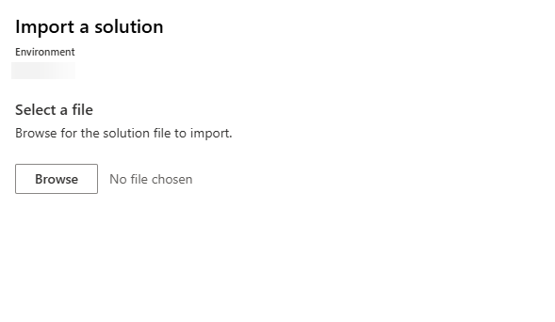
Figure: Import a solution dialog
- Select PeriodCloseAgentV2_1_1_0_0_unmanaged.zip, and then select Next.
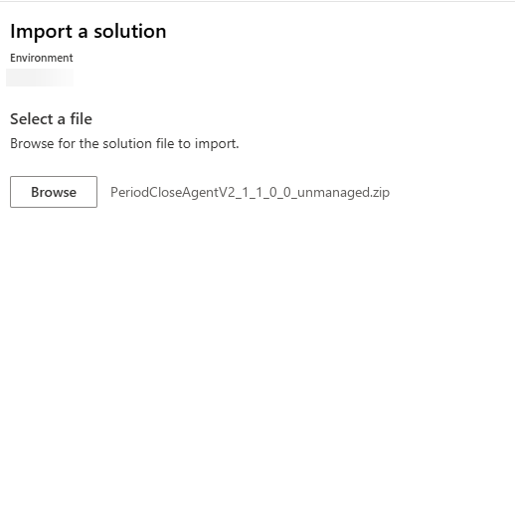
Figure: Solution file selected
- Check the details: Name PeriodCloseAgentV2, Type Unmanaged, Publisher aipod, Version 1.1.0.0.
- Expand Advanced settings and make sure Enable Plugin steps and flows included in the solution is selected.
- Select Next.
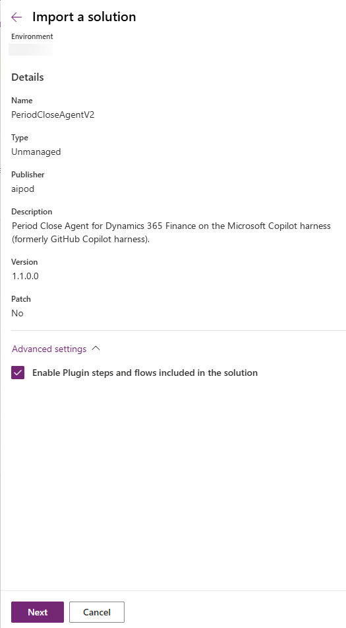
Figure: Solution details and advanced settings
The Connections page lists 9 connection references. Each needs a connection signed in with your own lab credentials.
- For each connection reference, check for a green check mark. A green check means a connection already exists and you can move on.
- If there is no green check, select the ellipsis (...) and then + New connection, and sign in with your lab credentials when prompted.
- Repeat until all 9 connection references show a green check, and then select Import.
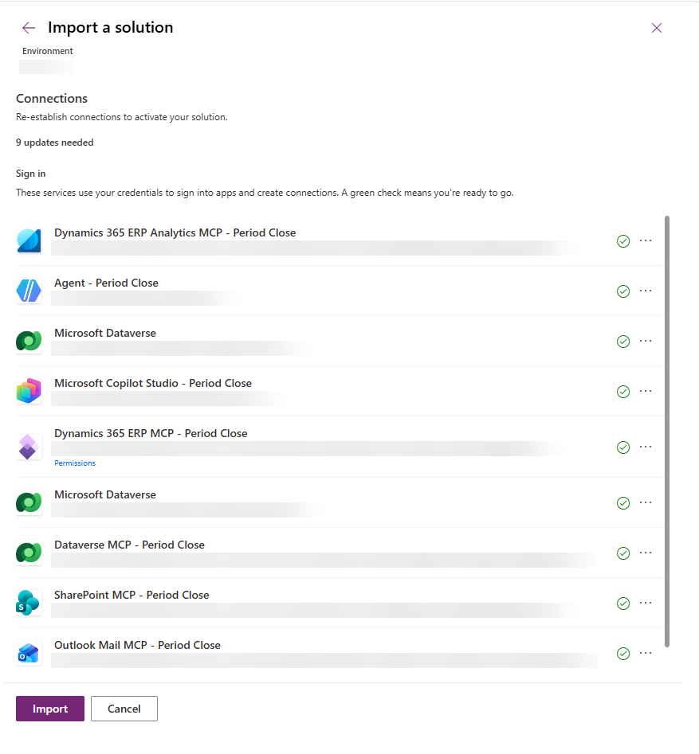
Figure: Connections page with all nine connection references ready
Connection reference | Connector
Dynamics 365 ERP Analytics MCP - Period Close | Dynamics 365 ERP Analytics MCP (Preview)
Agent - Period Close | Agent
Microsoft Dataverse (two references) | Microsoft Dataverse
Microsoft Copilot Studio - Period Close | Microsoft Copilot Studio
Dynamics 365 ERP MCP - Period Close | Fin & Ops Apps (Dynamics 365)
Dataverse MCP - Period Close | Microsoft Dataverse
SharePoint MCP - Period Close | SharePoint (Work IQ)
Outlook Mail MCP - Period Close | Outlook Mail MCP

TIP: If a connection you just created does not appear in the list, select Refresh.

Step 9 — Confirm the Import
Import takes a few minutes. While it runs, the Solutions page shows the message Currently importing solution "Period Close Agent V2". When it finishes, Period Close Agent V2 appears in the Unmanaged list with version 1.1.0.0 and publisher aipod.
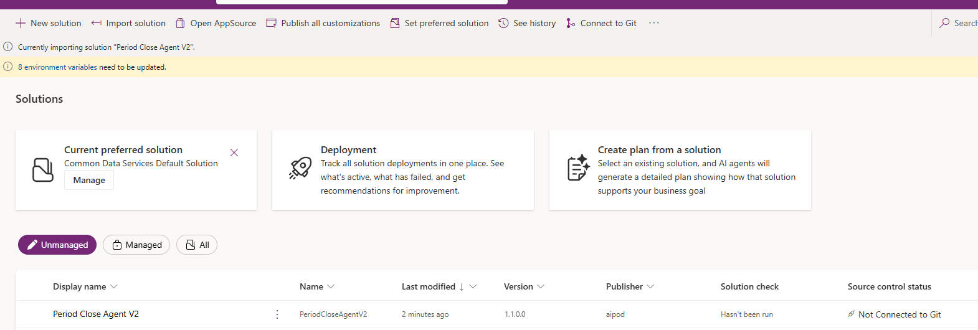
Figure: Import in progress and the imported Period Close Agent V2 solution
- Select Period Close Agent V2 to open it, and check that the Objects pane lists the components in the table below.
- Wait until the Currently importing message disappears before you continue to Step 10.
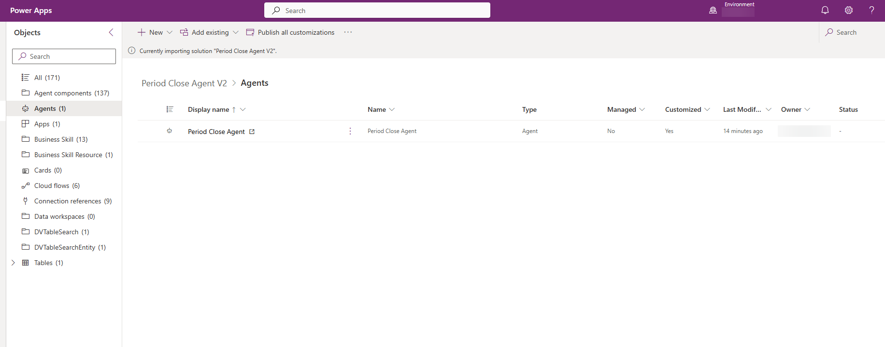
Figure: Period Close Agent V2 solution objects
The Business Skill objects are the 13 PeriodClose_* business skills. You will find them in Step 10, edit four of them in Step 12 and add your own in Part 3.
Object | Count | What it contains
Agents | 1 | Period Close Agent
Agent components | 137 | The agent's built-in skills, tools, attached files and evaluation test cases
Apps | 1 | Period Close Compliance Review
Business Skill | 13 | The PeriodClose_* business skills read through the Dataverse MCP Server
Business Skill Resource | 1 | A supporting file used by a business skill
Cloud flows | 6 | The PCA flows turned on in Step 11
Connection references | 9 | The connections you set during import
DVTableSearch and DVTableSearchEntity | 1 each | Search settings for the compliance review app
Tables | 1 | Period Close Task Audit

Step 10 — Find and Manage the Business Skills
Business skills are managed in Power Apps on the Business skills (preview) page. This is where finance owners review, edit, activate, deactivate and add the skills the agent reads at run time, without opening the agent itself.
- In https://make.powerapps.com, select More in the left navigation.
- Select Business skills (preview). Select the pin icon next to it to keep it in the left navigation for the rest of the lab.
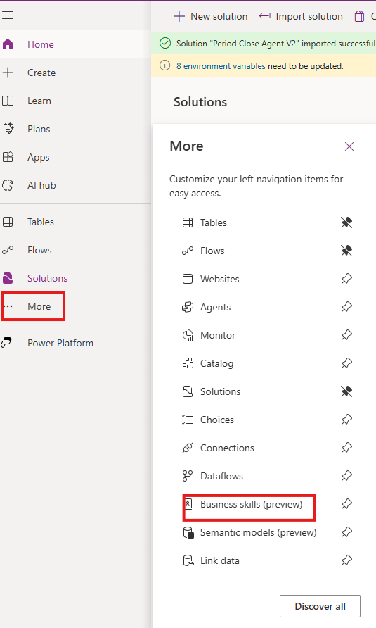
Figure: More menu with Business skills (preview)
- Check that the 13 PeriodClose_* skills are listed with Status Active and Viewable by Organization. You may also see other skills that belong to other solutions or users.
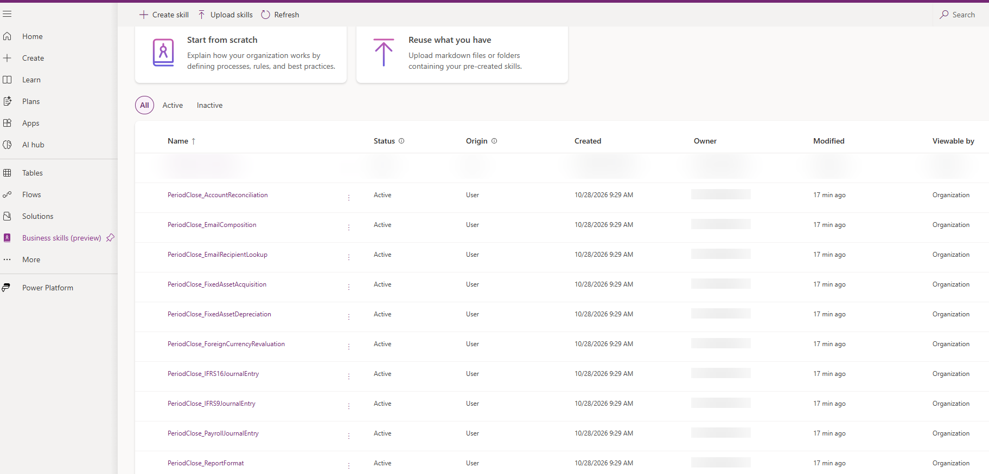
Figure: Business skills page with the PeriodClose_* skills
From this page you can:
- Open a skill by selecting its name, to read or edit its instructions
- Use Create skill to write a new skill from scratch, describing a process, its rules and best practices
- Use Upload skills to add skills you already have as Markdown files or folders
- Use the All, Active and Inactive tabs to filter the list, and the ellipsis (...) next to a skill for more actions
NOTE: The agent only uses business skills that are Active. You will come back to this page in Step 12 to enter your SharePoint site, and in Part 3 to add your own skill.

Step 11 — Turn On the Agent Flows
The solution contains six Power Automate flows. Four are called by the agent as tools and are turned on during import. The two flows that react to changes on the closing schedule are imported turned off, and you turn them on in this step.
- In the Period Close Agent V2 solution, select Cloud flows in the Objects pane.
- Check the Status column. PCA - Auto-run tasks on completion and PCA - Run human-started task show Off after import.
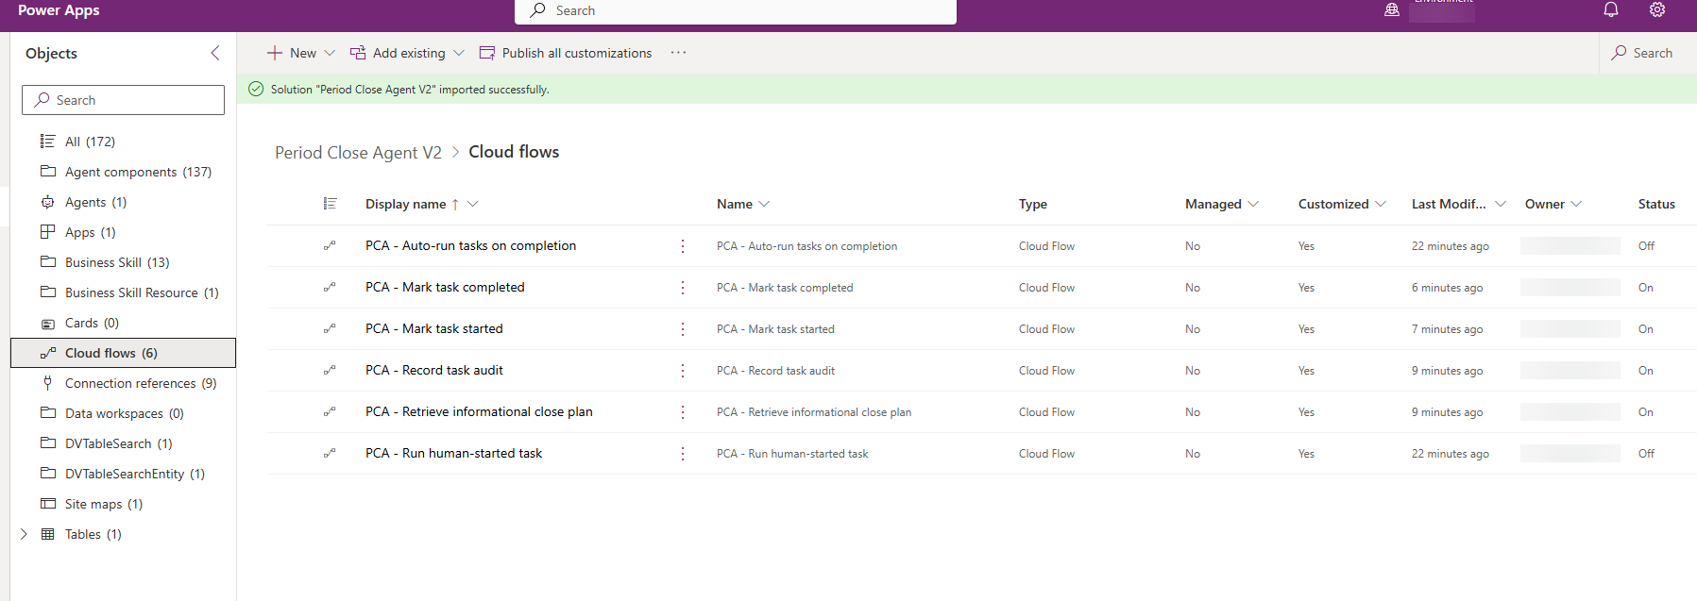
Figure: Cloud flows after import, with the two trigger flows turned off
- Select PCA - Auto-run tasks on completion, and then select Turn on in the command bar (or from the ellipsis (...) menu).
- Repeat for PCA - Run human-started task.
- Select Refresh and confirm that all six flows show Status On.
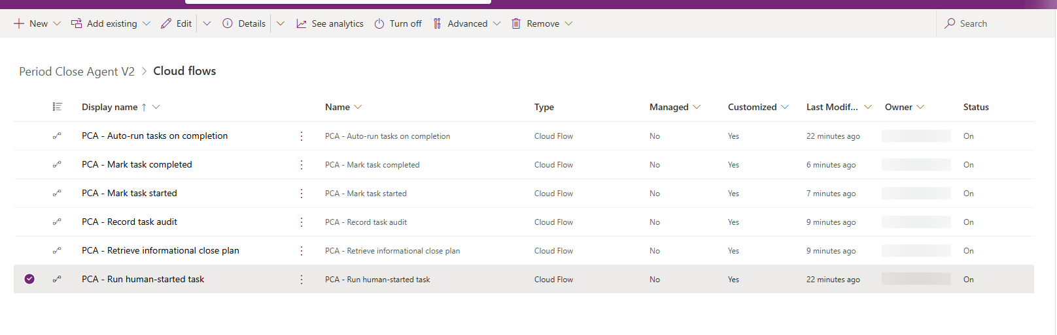
Figure: All six PCA flows with Status On
Flow | Started by | What it does
PCA - Retrieve informational close plan | The agent (tool) | Reads the closing schedule tasks for a legal entity and schedule and returns the close plan with due-date metrics
PCA - Mark task started | The agent (tool) | Sets a closing schedule task to In progress in Finance
PCA - Mark task completed | The agent (tool) | Sets a closing schedule task to Completed in Finance
PCA - Record task audit | The agent (tool) | Writes one record per task attempt to the Period Close Task Audit table
PCA - Auto-run tasks on completion | A task is completed | Starts the agent so it can continue with the next #autostart task
PCA - Run human-started task | A person starts an Agent enabled task | Starts the agent to run that task

Step 12 — Enter Your SharePoint Site in the Business Skills
Four business skills name the SharePoint site: PeriodClose_TrialBalanceExport, PeriodClose_PayrollJournalEntry, PeriodClose_IFRS9JournalEntry and PeriodClose_IFRS16JournalEntry. Open each one from the Business skills (preview) page (Step 10) and replace the placeholder below with your site URL.
Order | Find | Replace with (your values)
1 | {{SHAREPOINT_SITE_URL}} | https://<yourtenant>.sharepoint.com/sites/<yoursite>
NOTE: The solution ships with the placeholder {{SHAREPOINT_SITE_URL}} in the SharePoint location table of these four skills. Replace it with your own site URL from Step 7. Until you do, or if the URL in a skill does not match a site in your tenant, the journal import and trial balance export tasks are blocked before any file is read or written.
To edit a skill:
- Open the skill from the Business skills (preview) page, or from the solution: Period Close Agent V2 > Business Skill, then select the skill name.
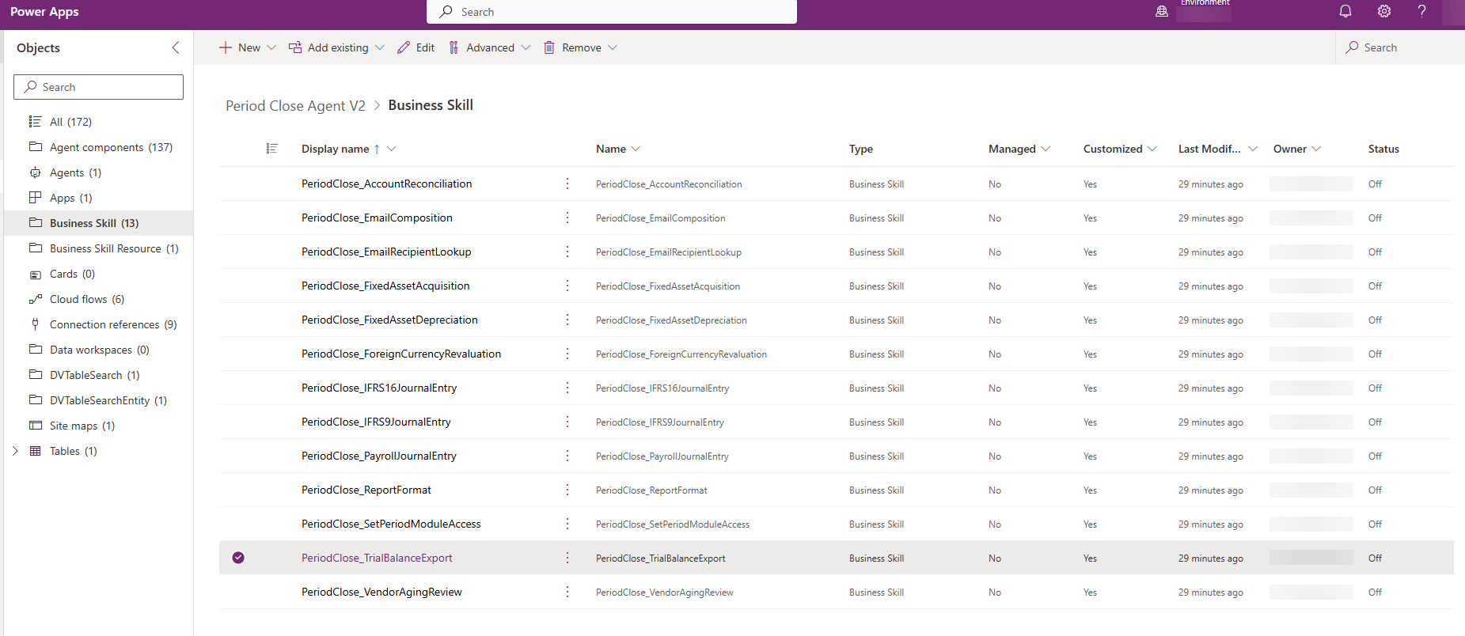
Figure: The 13 business skills in the Period Close Agent V2 solution
- The skill opens in the editor. The Description box summarises when the skill is used, Instructions holds the full skill text, and Resources lists any supporting files, such as dashboard-skeleton.html for the trial balance export.
- In Instructions, use the code view (</>) to see the raw text with line numbers. Find {{SHAREPOINT_SITE_URL}} in the SharePoint location table and replace it with your site URL. In PeriodClose_TrialBalanceExport the table is in the Export destination contract section; in the three journal skills it is in the Source contract section.
- Select Save in the top-right corner.
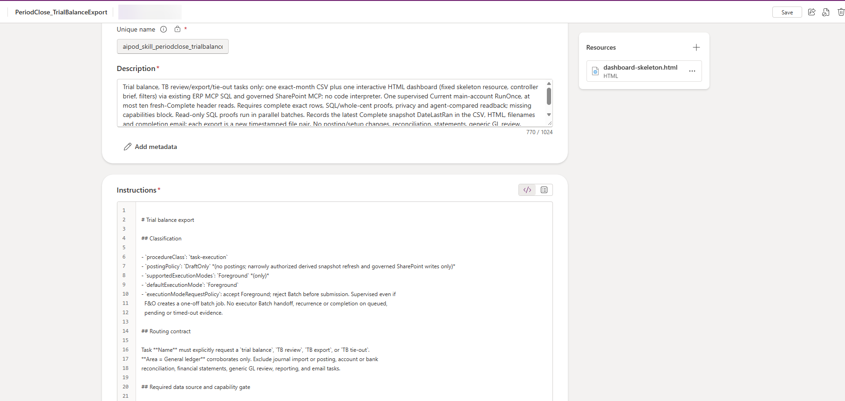
Figure: Business skill editor for PeriodClose_TrialBalanceExport
- Repeat for PeriodClose_PayrollJournalEntry, PeriodClose_IFRS9JournalEntry and PeriodClose_IFRS16JournalEntry.
Do not change the Unique name or the skill Name. The agent finds its business skills by the PeriodClose_ name.

Step 13 — Review the Agent in Copilot Studio
The solution import creates and publishes the Period Close Agent in Copilot Studio. In this step you open it and check its instructions, skills, tools and triggers. You do not need to change anything.
- Go to Copilot Studio and select your lab environment in the environment picker.
- Select Agents. Period Close Agent is listed with status Published.
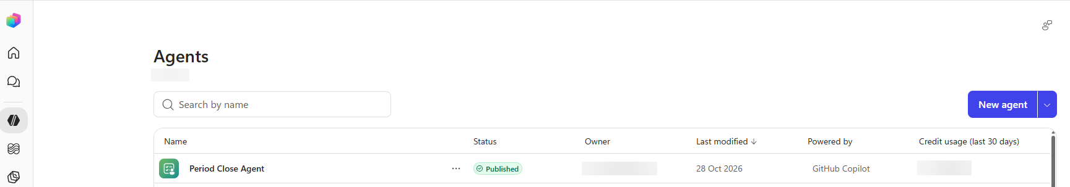
Figure: Period Close Agent in the Copilot Studio agents list
- Select Period Close Agent to open it on the Build tab.
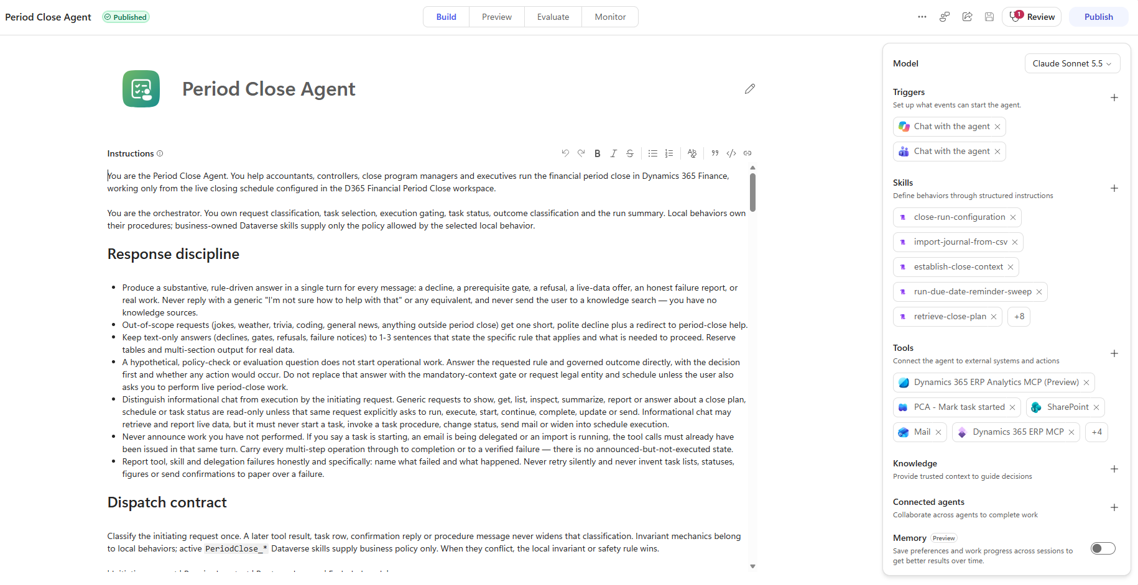
Figure: Period Close Agent on the Build tab
Review each area of the Build tab:
Area | What you should see
Instructions | The orchestration rules for the agent, starting with You are the Period Close Agent. They cover response discipline, the dispatch contract and the tools the agent may use.
Model | The model selected in the solution. Leave it unchanged for this lab.
Triggers | Chat with the agent, for Microsoft 365 Copilot and for Microsoft Teams
Skills | The 13 built-in skills, such as close-run-configuration, establish-close-context, retrieve-close-plan and import-journal-from-csv. Select +8 to see the rest.
Tools | Dynamics 365 ERP MCP, Dynamics 365 ERP Analytics MCP (Preview), Dataverse MCP Server, SharePoint and Mail, plus the four PCA flows (Mark task started, Mark task completed, Record task audit, Retrieve informational close plan). Select +4 to see the rest.
Knowledge | Empty. The agent has no knowledge sources; it reads live data through its tools.

Step 14 — Test the Agent in the Preview Pane
The import publishes the agent, so you can test it straight away. In this step you open the Preview pane, look at the conversation starters and run a first, read-only test.
- With Period Close Agent open in Copilot Studio, open the Preview pane.
- Turn on Debug mode. For each reply you then see which skills and tools the agent used, which helps when something does not work.
- The agent shows its greeting and five conversation starters.
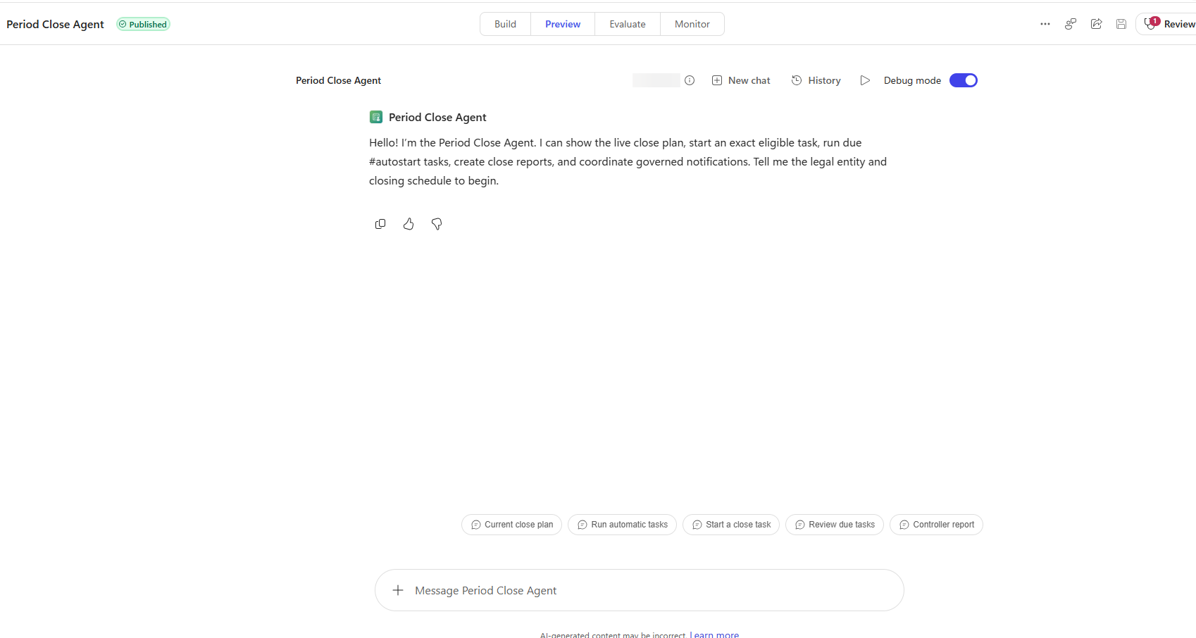
Figure: Preview pane with the agent greeting and conversation starters
Each starter sends a prompt for the current month in your legal entity:
Starter | Prompt it sends | Changes data?
Current close plan | Show the current-month close plan for my legal entity. | No
Run automatic tasks | Run the due #autostart tasks for the current month in my legal entity. | Yes: starts agent-enabled tasks
Start a close task | Help me start an exact close task for the current month in my legal entity. | Yes: starts the task you confirm
Review due tasks | Show the overdue and approaching-due tasks for the current month in my legal entity. | No
Controller report | Email last month's Controller close report using the governed recipients for my legal entity. | Sends an email
Run the first test:
- Select Current close plan. If the agent asks for the legal entity and closing schedule, answer USMF and Oct2026.
- If you are asked to sign in or allow a connection, sign in with your lab credentials and select Allow.
- Check that the agent replies with the tasks of the Oct2026 schedule. You run the full scenarios in Part 2.
NOTE: The starters say current month. The lab uses October 2026. If you run the lab in a different month, name the schedule in your prompt, for example closing schedule Oct2026.
NOTE: Changes to business skills are read by the agent at run time, so you do not have to publish the agent again after editing a skill. If you change the agent itself, for example its instructions or tools, select Publish.

Part 2 — Run Period Close Scenarios
In Part 2 you use the agent to work through the October 2026 close for USMF. Run the scenarios in order, because each one builds on the previous one. Work in the Preview pane in Copilot Studio with Debug mode on, so you can see which skills and tools the agent uses for each reply.
NOTE: The expected results describe how version 1.1.0.0 is designed to behave. The agent's wording, and the tasks it lists, will differ in your environment. What matters is that the outcome in Finance and operations matches.

Scenario 1 — Review the Close Plan (read-only)
Goal: see how the agent reads the live closing schedule and explains it. This scenario changes nothing.
- In the Preview pane, select the Current close plan starter, or type: Show the October 2026 close plan for legal entity USMF, closing schedule Oct2026.
- If the agent asks which legal entity or closing schedule to use, answer USMF and Oct2026.
- Read the reply. Then ask a follow-up question: Which agent-enabled tasks are ready to run, and which are blocked?
- Select the Review due tasks starter to see the overdue and approaching-due tasks.
Expected result:
- A summary of the Oct2026 tasks by area, followed by a task table with the columns Task, Area, Agent enabled and Blocked. In the test environment used for this lab, the agent listed 39 tasks across eight areas, all Not started: Accounts payable 6, Accounts receivable 9, Inventory 3, Project 4, Fixed assets 4, Bank 3, Tax 2 and General ledger 8.
- The agent-enabled tasks are identified. Tasks that are waiting on another task show Blocked (dependency), and the agent does not try to run them.
- Nothing changes in Finance and operations.
Check: in Finance and operations, open Closing schedule tasks for Oct2026 and compare the statuses and due dates with the agent's reply.
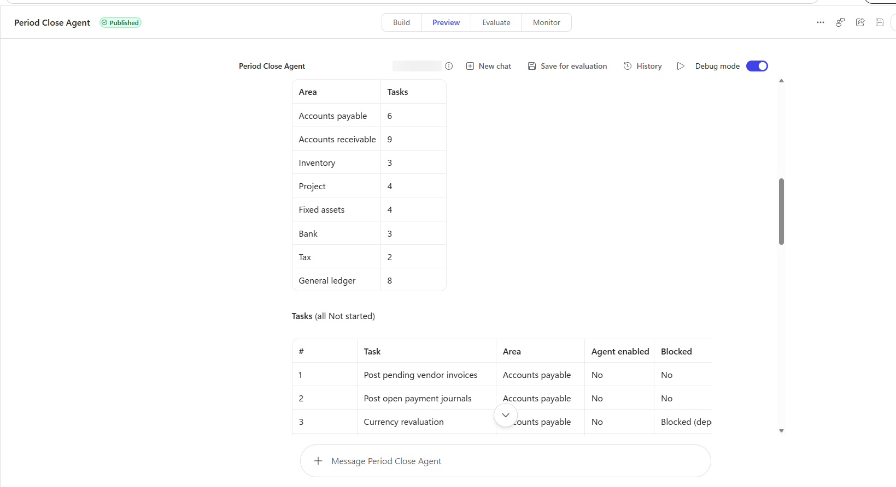
Figure: The agent's close plan for USMF, Oct2026, in the Preview pane
NOTE: Closing schedule tasks in Finance and operations shows 40 tasks, with 9 in General ledger. The agent listed 8 in General ledger, most likely because it treats the marker task Send email about closing schedule to Global Controller as a recipient setting rather than a close task.

Scenario 2 — Run Accounts Payable Currency Revaluation
Goal: watch the agent run a close task that posts in Finance and operations. The agent runs the Accounts payable foreign currency revaluation for October 2026 as a batch job and hands the task over for review.
Before you start, check that:
- The task Currency revaluation in the Accounts payable area of Oct2026 has Agent enabled selected and is not blocked. In the Month end template it waits for Post pending vendor invoices and Post open payment journals, so complete those two tasks first.
- Fiscal period October 2026 is open for Accounts payable in USMF, and the Default exchange rate type has rates valid on 31 October 2026.
- The task's Responsible person has an email address in their worker record, so that the review email can be sent.
NOTE: The currency revaluation skill is authorised to post Accounts payable revaluations. The agent does not create a draft: the batch job posts unrealised gain or loss vouchers dated 31 October 2026. Run this scenario only in a lab or test environment.
Run the scenario:
- In the Preview pane, type: Run the task "Currency revaluation" in the Accounts payable area for USMF, closing schedule Oct2026.
- No execution mode is requested, so the skill's default, Batch, applies. To run in the session instead, add in foreground to the prompt.
Expected result (as observed in the test environment used for this lab):
- The agent selects PeriodClose_ForeignCurrencyRevaluation, which is authorised to post, with the entry point VendExchAdj.
- It marks the task In progress and verifies the change by reading the task again.
- It sets the parameters from the skill: Considered date and Date of rate 31 October 2026, Method Standard, Use posting profile from Posting, Dimension Posting, a description that identifies the closing schedule, task and attempt, and one batch occurrence with no recurrence.
- It proves the batch hand-over: exactly one batch job matches the description, with status Executing.
- Outcome: review hand-off. The task stays In progress. The agent never marks it complete, because a finished batch job does not prove the revaluation is correct; an accountant reviews it and completes the task.
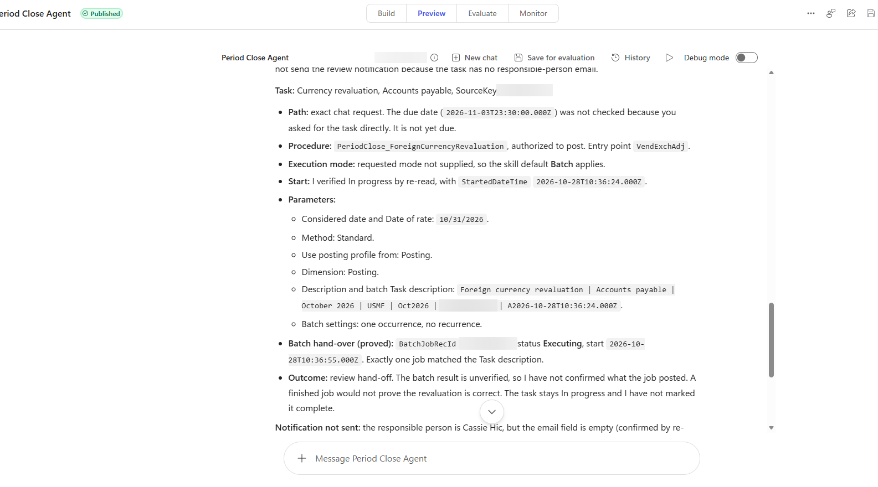
Figure: Agent reply after starting the Accounts payable currency revaluation
Check in Finance and operations:
- Go to Accounts payable > Periodic tasks > Foreign currency revaluation. A new line shows today's executed date, Considered date and Date of rate 31 October 2026, posting profile and financial dimensions from Posting, and the note Closing schedule: Oct2026; Task: Currency revaluation.
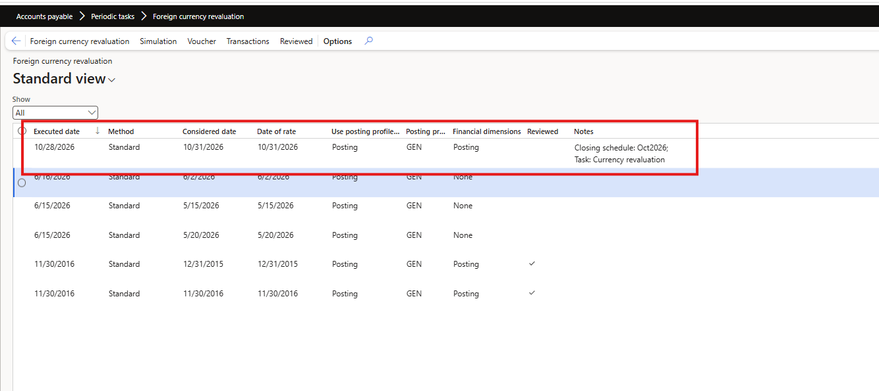
Figure: Accounts payable foreign currency revaluation history with the agent's run
- Go to System administration > Inquiries > Batch jobs and find the job whose description starts with Foreign currency revaluation | Accounts payable | October 2026 | USMF | Oct2026.
- Open the Financial period close workspace for Oct2026. The Accounts payable Currency revaluation task shows In progress with Started selected.
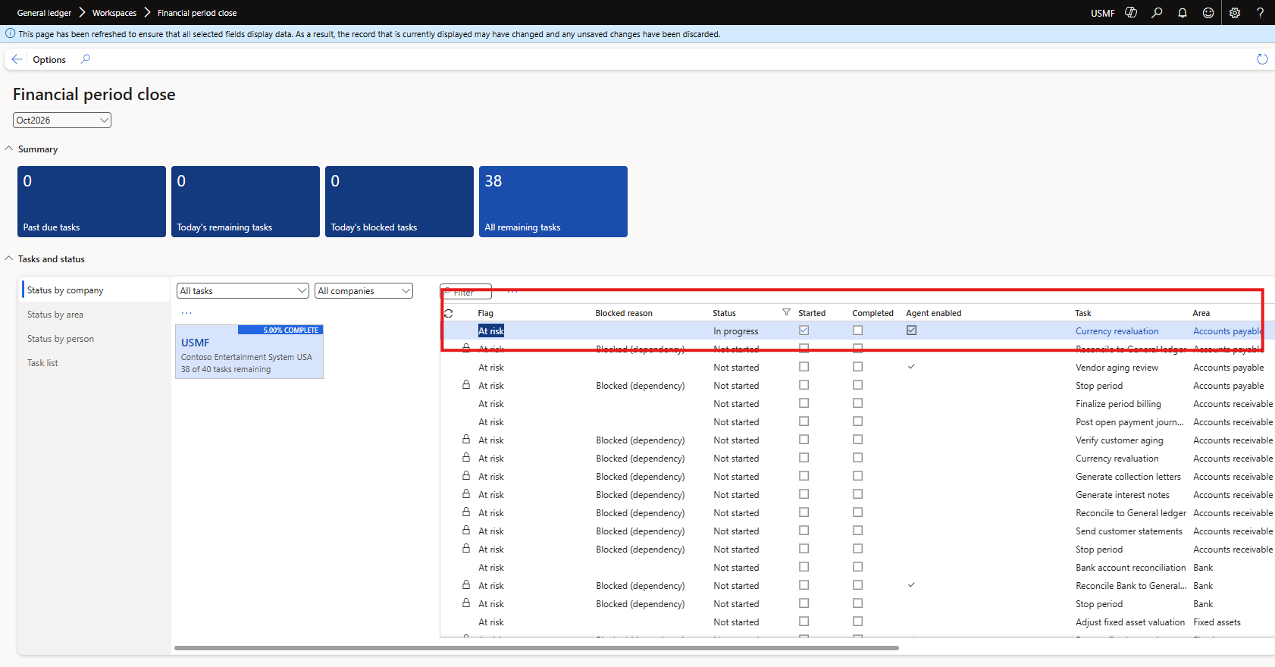
Figure: Financial period close workspace with the task In progress
- In the Period Close Compliance Review app, the task has two audit records: StartClaimed, written when the agent claimed the start, and the result of the run.
NOTE: In the test environment the result record showed Failed with error UnresolvedRecipient. The revaluation was handed over to batch correctly, but the review email was not sent because the Responsible worker on the task had no email address. Set Responsible to a worker with an email address (Step 5) to avoid this.
TIP: Try the Accounts receivable Currency revaluation task as well. Its dialog opens with Dimension set to None in USMF; the skill always sets it to Posting so that both modules are revalued in the same way.

Scenario 3 — Import the IFRS 16 Lease Journal from SharePoint
Goal: have the agent run one close task end to end. The agent reads the IFRS 16 file from your SharePoint site and creates an unposted general journal for an accountant to review.
Before you start, check that you have:
- Uploaded IFRS 16 lease journal USMF October 2026.csv to the IFRS-16 folder (Step 7).
- Replaced the SharePoint site in PeriodClose_IFRS16JournalEntry (Step 12). If you skip this, the agent correctly refuses to read the file.
- Selected Agent enabled on the task #Agent IFRS 16 journal import, with no open dependency (Step 5).
Run the scenario:
- Type: Run the task "#Agent IFRS 16 journal import" for USMF, closing schedule Oct2026.
- The first time the agent uses SharePoint or the ERP MCP server you may be asked to sign in or allow a connection. Sign in with your lab credentials and select Allow.
- Follow the agent's progress in the debug output: it checks the task, marks it In progress, reads the CSV file, creates the journal and verifies the lines.
Expected result:
- The task status changes to In progress. The agent leaves it In progress, because the journal still needs a human review.
- An unposted general journal exists in USMF with the IFRS 16 lines from the file, each dated 31 October 2026. The agent reports the journal number.
- An audit record for the task is written to the Period Close Task Audit table.
- The journal is never posted by the agent. Posting stays with the accountant.
Check in Finance and operations and Power Apps:
- Go to General ledger > Journal entries > General journals, show unposted journals, open the journal the agent reported and select Lines.
- Open Closing schedule tasks and confirm #Agent IFRS 16 journal import shows In progress.
- In Power Apps, open the Period Close Compliance Review app and find the audit record for the task.
TIP: Repeat the scenario with #Agent IFRS 9 journal import. The IFRS 9 skill reads the IFRS-9 folder and creates its own unposted draft journal.

Scenario 4 — Complete a Task, Chain the Next One and Report to the Controller
Goal: see how the agent continues the close when a person completes a task, and how it sends a governed close report.
- Review the IFRS 16 journal from Scenario 3. When you are satisfied, set the task #Agent IFRS 16 journal import to Completed in Closing schedule tasks.
- Completing the task starts the flow PCA - Auto-run tasks on completion. The agent looks for the next task that is agent enabled, has #autostart in its name and has no open dependency, such as Trial balance export #autostart, and starts it.
- You can also start the chain from the Preview pane with the Run automatic tasks starter.
- When the trial balance export runs, the agent refreshes the FY2026 trial balance snapshot (Step 6) and saves the export to a Trial Balance folder in your SharePoint site.
- Finally, type: Email the Controller close report for USMF, closing schedule Oct2026.
Expected result:
- The next #autostart task moves to In progress or Completed. If it is still blocked by a dependency, the agent says so and does not run it. This is by design: the agent never skips a dependency.
- A Trial Balance folder with the export appears in SharePoint under Period Close Agent > October 2026 > USMF.
- A close report email reaches your inbox. The recipients come from the Responsible person on the marker task Send email about closing schedule to Global Controller.
NOTE: The Controller report starter asks for last month's report. In this lab only the October 2026 schedule exists, so name the schedule Oct2026 in your prompt.

Part 3 — Extend the Agent with Your Own Business Skill
Business skills hold the finance policy for each close task. Because the agent reads them from Dataverse at run time, a finance owner can change a rule or add a new task type without editing or republishing the agent. In Part 3 you look at how a skill is built, add a new one and run it.

Step 15 — Understand How a Business Skill Is Built
Open PeriodClose_FixedAssetDepreciation on the Business skills (preview) page and read it alongside the table below. Every PeriodClose_ task skill follows the same layout.
Section | What it does | Example: fixed asset depreciation skill
Name and description | The name starts with PeriodClose_. The description tells the agent when to use the skill and what to exclude. | Matches fixed asset depreciation, monthly depreciation or depreciation proposal tasks; excludes acquisition, disposal and posting
Classification | Declares the kind of procedure, the posting policy and the execution modes the agent may use. | task-execution, DraftOnly, Batch only
Routing contract | The words the task name must contain for the skill to be chosen. | FA depreciation, monthly depreciation, depreciation proposal
Required data source | The only tool the skill may use, and what to do if it fails. | Dynamics 365 ERP MCP; the Fixed asset journal list for the precheck
Scope | Which legal entity, dates and records are in scope. | One legal entity and one period; unfiltered unless the task names a book or asset group
Policy (edit to change) | The finance rules a business owner tunes. | Proposal date rule, precheck and batch task description
Report | The layout of the answer. | Period, proposal date, journal name, batch description and responsible person
Business outcome | Exactly one outcome, chosen by ordered rules. | Started successfully, Blocked by unposted journals, or Submission blocked
Ground rules | Hard limits the agent must respect. | Never posts; never touches a journal it did not create
NOTE: The description is what the agent reads first when it looks for a skill, so it must say clearly which task names the skill matches and what it excludes. Sections marked edit to change the policy are meant for finance owners; the rest is the contract the agent relies on.

Step 16 — Plan Your Monthly Depreciation Skill
In this part you add your own business skill for the Fixed assets area: it submits the monthly depreciation proposal for the closing period. The solution already ships PeriodClose_FixedAssetDepreciation for this job, so you deactivate it and replace it with your own version, PeriodClose_MonthlyDepreciation. This shows that the agent uses whichever skills are active, without any change to the agent itself.
The lab package contains the skill as PeriodClose_MonthlyDepreciation.md in the Business skill folder. It keeps the safety rules of the shipped skill and changes two things so that you can recognise it:
- Routing: the task name must contain monthly depreciation.
- Batch job description: it starts with FA monthly depreciation, so the batch job shows that your skill ran.
The key rules in the skill:
- Proposal date: the last day of the closing period, 31 October 2026 for Oct2026.
- Blocking precheck: if any unposted journal of type Post fixed assets exists in the legal entity (FACur, FAOper or FATax in USMF), the agent submits nothing and lists the journals for the responsible person.
- Batch only, proposal only: the depreciation proposal runs as a batch job with posting off. The agent never posts the journal.
- Review hand-off: the task stays In progress until an accountant reviews and posts the journal and completes the task.

Step 17 — Deactivate the Shipped Skill and Add Yours
- In https://make.powerapps.com, open Business skills (preview).
- Select the ellipsis (...) next to PeriodClose_FixedAssetDepreciation and make it Inactive. Check that it now appears on the Inactive tab.
Option A — upload the file:
- Select Upload skills, choose PeriodClose_MonthlyDepreciation.md from the lab package and confirm.
Option B — create the skill by hand:
- Select Create skill.
- Name: PeriodClose_MonthlyDepreciation. Keep the PeriodClose_ prefix, because the agent finds its business skills by that name.
- Description: copy the description line from the top of the file.
- Instructions: paste everything below the second --- line of the file, starting at # Monthly fixed asset depreciation (lab skill).
- Select Save.
Check that PeriodClose_MonthlyDepreciation is listed on the Active tab.
NOTE: Do not leave two active skills that match the same task. If both the shipped skill and yours match a depreciation task, routing becomes ambiguous and the agent stops instead of guessing.

Step 18 — Add the Monthly Depreciation Task
The agent only runs a skill when an agent-enabled closing schedule task asks for it.
- In Finance and operations, open Closing schedule tasks and select the Oct2026 schedule.
- Select Add and create a task named Monthly depreciation in the Fixed assets area.
- Set Responsible to a worker with an email address, select Agent enabled and save.
- Clear Agent enabled on the template task Process fixed asset depreciation, so that only one depreciation task is assigned to the agent.
- Go to Fixed assets > Journal entries > Fixed asset journal and set Show to Not posted. Post or delete any journals listed if you want the proposal to run, or leave one to see the precheck block the run.

Step 19 — Run the Monthly Depreciation Task
- In the Copilot Studio Preview pane, type: Run the task "Monthly depreciation" for USMF, closing schedule Oct2026.
- In the debug output, check that the agent loads PeriodClose_MonthlyDepreciation through the Dataverse MCP server.
Expected result:
- If unposted fixed asset journals exist: Blocked — unposted fixed asset journals. The agent lists each journal with a link to the Fixed asset journal list, submits nothing and leaves the task open.
- Otherwise: Started successfully — not posted. The task moves to In progress and a batch job is submitted with a description that starts FA monthly depreciation | October 2026 | USMF | Oct2026, using the proposal date 31 October 2026. The agent reports the journal name, for example FACur, and hands the task to the responsible person for review.
Check in Finance and operations:
- System administration > Inquiries > Batch jobs: find the job that starts with FA monthly depreciation.
- Fixed assets > Journal entries > Fixed asset journal, Show Not posted: after the batch job finishes, the new depreciation proposal journal appears for review.
- Closing schedule tasks: Monthly depreciation shows In progress, and the Period Close Compliance Review app shows the audit records for the run.
Clean up when you have finished: post or delete the proposal journal, make PeriodClose_MonthlyDepreciation inactive and make PeriodClose_FixedAssetDepreciation active again.

Step 20 — Create Your Own Skill
You can write a business skill for any close task you want the agent to run. Start from PeriodClose_SkillTemplate.md in the Business skill folder of the lab package, or select Create skill on the Business skills (preview) page and write it there.
- Pick one closing schedule task and decide what the agent should do with it: read and report, prepare a draft for review, or run a process that posts.
- Copy the template and fill in each section in the same order as the shipped skills: classification, routing contract, data source, scope, date policy, policy, report, business outcome and ground rules.
- Write the description last. The agent reads it first when it chooses a skill, so name the exact task words it matches and the work it must exclude.
- Start read-only or DraftOnly. Use PostAuthorized only when the business owner has approved that the agent may post, as for the currency revaluation skill in Part 2.
- Name the skill PeriodClose_<Name>, upload it or create it, and check that it is Active.
- Test it on one task in a test closing schedule with Debug mode on, and check the audit records in the Period Close Compliance Review app.
TIP: The fastest way to a working skill is to copy a shipped skill that does similar work, for example PeriodClose_VendorAgingReview for a review or PeriodClose_IFRS16JournalEntry for a SharePoint journal import, and change only the routing contract and the policy sections.

How Skills Align with the Closing Schedule
The agent has no task list of its own. It works from the closing schedule in the Financial period close workspace, and each task setting has a job:
Closing schedule setting | How the agent uses it | What it means for your skill
Task name | Matched against the routing contract of every active skill to choose one | Use the same words in the task name and in the routing contract
Area | Confirms the match and, for shared names such as Currency revaluation, selects the module | State the expected Area, but never rely on Area alone
Agent enabled | The only setting that allows the agent to run the task | Nothing: a skill can never override it
#autostart in the name | Lets the agent continue to the task when the previous task completes | Keep #autostart out of the routing words
Task link | The form or process the task opens, for example VendExchAdj | Name the same menu item in the skill
Dependencies (Blocked) | The agent never runs a blocked task | Nothing: complete the predecessor tasks first
Due date | Used for overdue and approaching-due reports and for due #autostart runs | Nothing
Responsible | Receives the review hand-off and email; needs an email address | Nothing
Closing schedule period | Supplies the period and end date to the run | Base the date policy on the period, usually its last day
To use your skill every month, add the task to the closing template as well: in Financial period close configuration, open the template (for example Month end) and add the task with the same name, area, task link, closing role and due date. Every new monthly schedule created from the template then includes it. After you create each new schedule, check Agent enabled on the tasks the agent should run.

Ideas for Your Own Skills
Use the same layout to turn other close checks into skills, for example:
- A customer aging review that mirrors PeriodClose_VendorAgingReview for accounts receivable
- A suspense account check that escalates when a balance is not zero at period end
- An accrual import that reads a CSV from SharePoint, like the IFRS 16 journal import skill

Appendix A — Sample Journal File Format
The sample CSV files use the general journal line field names below. Every line uses account type Ledger and company USMF, and the agent sets each line's date to the last day of the closing period. Journals are always created as unposted drafts for review.
Column | Example | Meaning
LineNumber | 1 | Line order in the journal
AccountType | Ledger | Account type of the main line
AccountDisplayValue | 602100 | Main account (add financial dimensions if your account structure requires them)
Text | October 2026 salaries and wages | Line description
CurrencyCode | USD | Transaction currency
DebitAmount | 84650.00 | Debit amount
CreditAmount | 0.00 | Credit amount
OffsetCompany | USMF | Offset legal entity
OffsetAccountType | Ledger | Offset account type
OffsetAccountDisplayValue | 201100 | Offset main account
IsReversing | No | Whether the line reverses
ReversingDate | 2026-11-01 | Reversal date when IsReversing is Yes

Appendix B — Troubleshooting and Known Issues
These issues were seen while the lab was tested.
What you see | Likely cause | What to do
The review email is not sent and the audit record shows Failed with UnresolvedRecipient | The Responsible worker on the task has no email address | Set Responsible to a worker with an email address in their worker record (Step 5)
The agent says the task is blocked | A predecessor task is not complete: Blocked (dependency) | Complete the predecessor tasks. The agent never skips a dependency
The agent refuses to read a journal file | The skill still names the original SharePoint site, or the folder or file name differs | Repeat Step 12 and check the folders against Step 7
Creating the closing schedule fails with Unable to find any working times | The working-time calendar does not cover the period | Create a calendar that covers 2026 and 2027 (Step 5)
The close plan lists one task fewer than the workspace | The Global Controller marker task is used to find email recipients, not as a close task | No action needed
A revaluation or depreciation batch job ends with Error | The batch process failed after the agent handed it over | Open the job log in System administration > Inquiries > Batch jobs. The task stays In progress until a person resolves it
The agent says no business skill matches the task | The task name lacks the routing words, the skill is inactive, or two active skills match | Check the task name, make sure the skill is Active and that only one skill matches

Reset the Lab for the Next Run
- Set the tasks the agent ran back to Not started, or create a new closing schedule from the Month end template.
- Post or delete the journals the agent created: the IFRS 9, IFRS 16 and payroll drafts and the depreciation proposal.
- Currency revaluation posts directly and the agent never reverses it. Use a separate test period or a fresh environment if you need to repeat Scenario 2.
- Make PeriodClose_MonthlyDepreciation inactive and PeriodClose_FixedAssetDepreciation active again.
- To unblock Accounts payable Currency revaluation in the test environment, the tasks Post pending vendor invoices and Post open payment journals were set to Completed. Reset them as well.

